Admin Website Management

**Robinson Meng**

After install testrail, you can administrate in website. When you click Administration, you can see these setting. It included setting of Projects, Users & Roles, Customizations, Integration, License, Site Settings and System Log.

REVISION HISTORY

|  |  |  |
| --- | --- | --- |
| REVISION | RELEASE DATE | COMMENTS |
| V1.0 | 11/23/2014 | Initial draft |

CONTENTS

1 Projects 4

2 Users & Roles 5

3 Customizations 7

4 Integration 11

5 License 11

6 Site Settings 12

7 System Log 13

8 Appendix 14

1. Projects

You can edit exist project or add a new project in this section.

* 1. Add Project

When you add a new project, you can enter its name and select “**Use multiple test suites to manage cases**”.

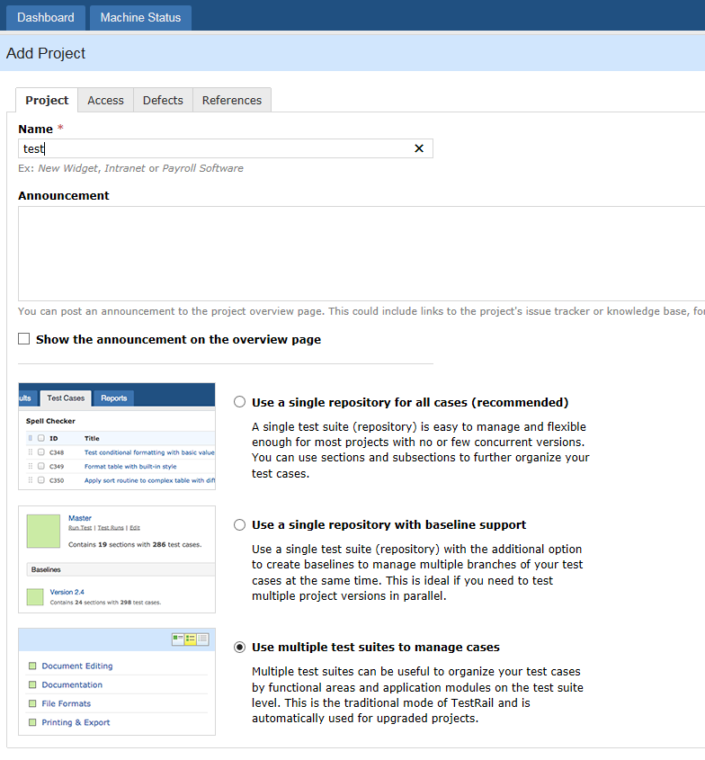

* 1. Access setting

After a new project was added, you can set the users access to the project.

If users only do testing, you can set him to Tester.

And setting to Leader,which means he has permission to creat projct.

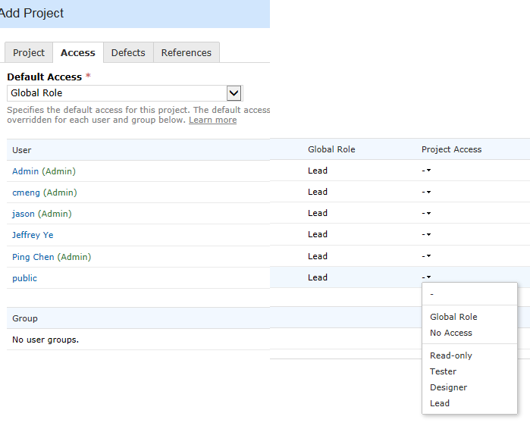

1. Users & Roles

In this tab you can manager users, groups and permissions and controlling project access.

2.1 Add users with the Role(Lead or Tester). And set this user to active or administrator by following tab.

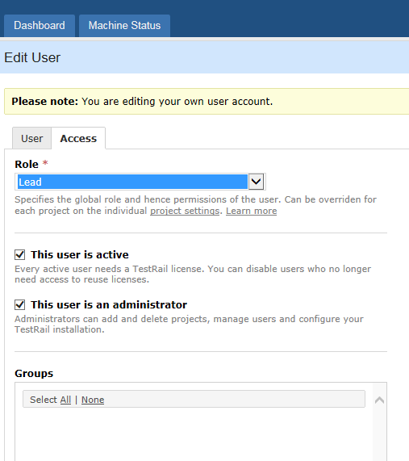

2.2 The Role of Tester or Leader can be modfied in next tab.

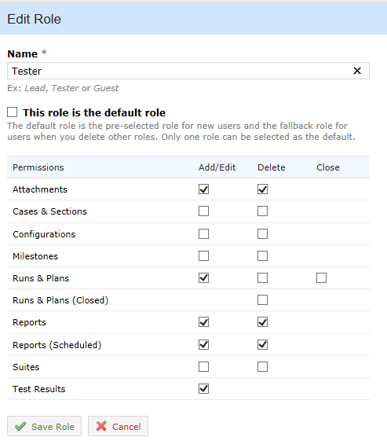

3. Customizations

3.1 Case Fields

Case names are Estimate(String), Milestone(Milestone), References(String), Test Level(Dropdown), Configuration(Text), Preconditions(Text), Test Scenarios(Text), Description(Text), Steps(Text), Expected(Text),they are in System.

You can customize other case name and type. Such as Family(String),Slice(Integer), PIO(Integer), RTL Case(Dropdown), Flow(String) in your case.

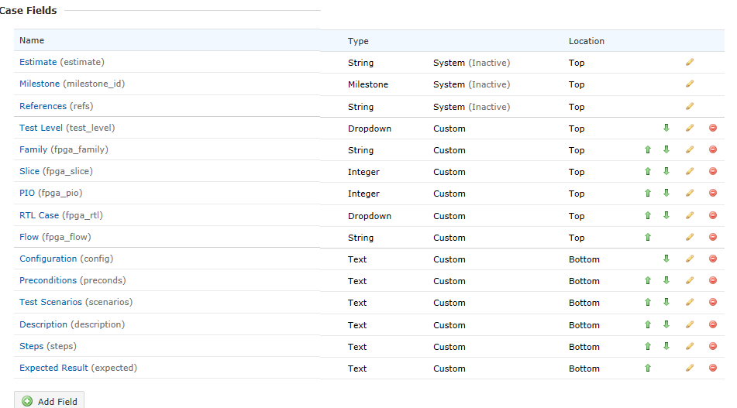

3.2 Result Fields

The Version, Elapsed and Defects, which type is string, they are System type. They can't been modified. You can add your Label, Location and Reason in the fields.

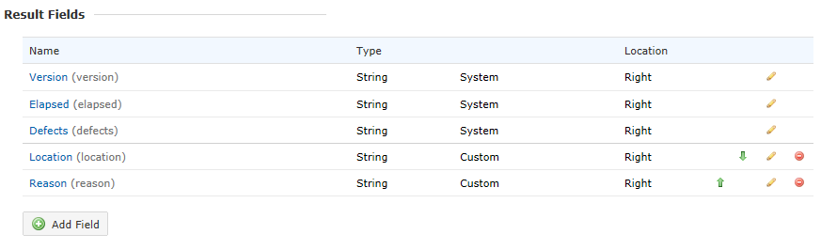

3.3 Case Types

It included Acceptance, [Accessibility](http://linux-d50553/testrail/index.php?/admin/case_types/edit/2), [Automated](http://linux-d50553/testrail/index.php?/admin/case_types/edit/3)…, see the following pic.

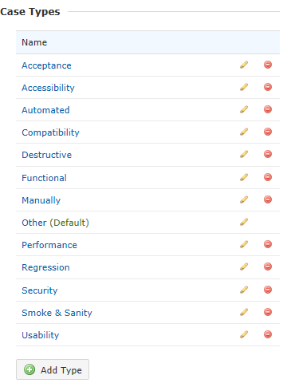

3.4 Priorities

There are Critical, High, Medium and Low in priority.

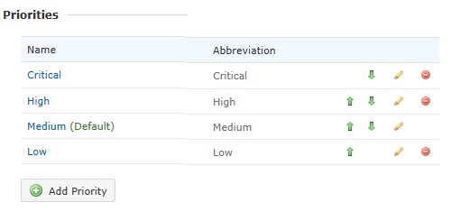

3.5 Statuses

You can edit a system status in this setting tab. Such as Passed, Failed, Processing, TBD, etc…

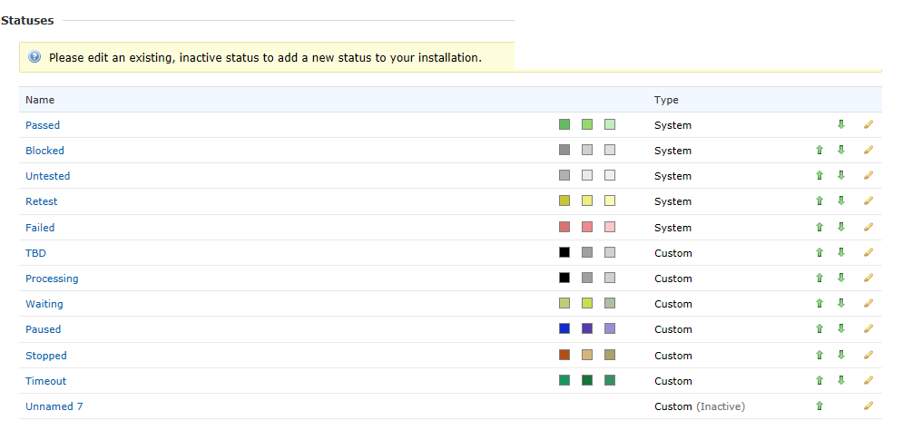

3.6 UI Scripts

You can add UI Script here. In the tab you can enter or paste the configuration and source code for the UI script. The script can contain JavaScript or CSS code to customize your TestRail installation.

See following pic.

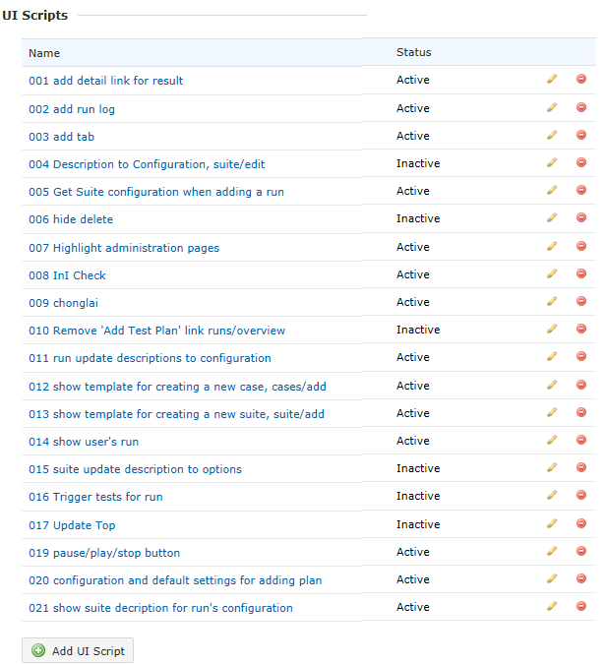

The script file can been seen in Appendix.

4. Integration

You can set up the integration between JIRA and TestRail. The integration enables you to view JIRA issues and add new issues directly from TestRail.

5. License

When you install testrail, the License Key is needed. You can see the license key in this setting.

You can order additional licenses or extend your licenses. And you can see license type, expiration date and users.

6. Site Settings

When you install testrail, the following setting will be setup. There is no need to change agin.

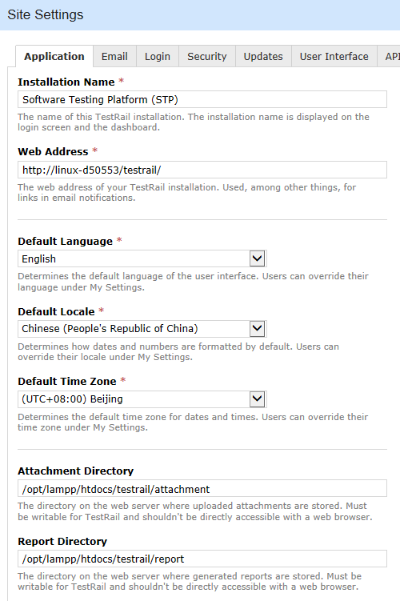

7. System Log

The system log shows diagnostic and informational messages and helps troubleshoot possible issues with your TestRail installation.

You can check the log file.

Appendix

**001 add detail link for result**

description:

author: yu

version: 1.0

includes: ^runs/view

excludes:

js:

$(document).ready(

function() {

$("ul.header-menu").append('<li class="header-menu-item"><a tabindex="-1" href="http://linux-d50553/test/lrf20/index.php?r=result/index&runId='+uiscripts.context.run.id+'&projectId='+uiscripts.context.project.id+'">Detail Report</a></li>');

}

);

css:

div.some-class {

**}**

**002 add run log**

description: add run log for cases

author: yzhao

version: 1.0

includes: ^tests/view

excludes:

js:

$(document).ready(

function() {

$("#content-inner>.button-group.form-buttons").append('<a id="assign" href="javascript:void(0)" onclick="showlog();" class="button button-left button-view">ShowLog</a>');

$("#content-inner>.button-group.form-buttons").after('<div style=" border-width: 1px; border-style: solid;border-color: #d7d7d7; padding-top:10px" id="runLog"></div>')

}

);

function showlog(){

if(1){

var url = "http://linux-d50553/test/lrf20/index.php?r=result/log";

var testId = uiscripts.context.test.id;

var data = "testId="+testId ;

//var data = "testId="+17087;

$.ajax({

type:'GET',

url:url,

dataType:'text',

data:data,

error:function(){$("#runLog").html('Can not find log')},

success:function(return_data){

if(1){

$("#runLog").html(return_data);

}

}

})

}

}

css:

div.some-class {

}

**003 add tab**

description: Shows a 'Hello, world!' message on the dashboard

author: yzhao

version: 1.0

includes:

excludes:

js:

$(document).ready(

function() {

$("ul.header-menu").append('<li class="header-menu-item"><a target="_blank" tabindex="-1" href="http://linux-d50553/test/lrf20/index.php?r=machineStatus/admin">Machine Status</a></li>');

//$("ul.header-menu").append('<li class="header-menu-item"><a tabindex="-1" href="http://d27614/test/lrf20/index.php?r=result/index">Detail Report</a></li>');

}

);

css:

div.some-class {

}

004 Description to Configuration, suite/edit

description: ...

author: Shawn Yan, 2016/5/12

version: 1.0

includes: ^suites/edit

excludes:

js:

$(document).ready(

function() {

var miao = "<span class=\"form-toolbar\" style=\"padding-top: 0px\"> " +

"<a href=\"javascript:void(0)\" onclick=\"this.blur(); App.Editor.addTable('#description'); " +

"return false;\" class=\"link-tooltip\" tooltip-text=\"Add a table to this text field.\"" +

"tabindex=\"-1\"> <img src=\"images/icons/markdownTable.png\" width=\"16\" height=\"16\" "+

" alt=\"\" /></a> <a href=\"javascript:void(0)\" onclick=\"this.blur(); "+

"App.Editor.addImage('#description', 2); return false;\" class=\"link-tooltip\" " +

"tooltip-text=\"Add an image to this text field.\" tabindex=\"-1\"> " +

" <img src=\"images/icons/markdownImage.png\" width=\"16\" height=\"16\" alt=\"\" " +

" /></a> <a href=\"http://docs.gurock.com/testrail-userguide/userguide-editor\" " +

"class=\"link-tooltip\" tooltip-text=\"Open the editor formatting reference.\" " +

" target=\"_blank\" tabindex=\"-1\"> <img style=\"margin-right: 0\" " +

"src=\"images/icons/markdownHelp.png\" width=\"16\" height=\"16\" alt=\"\" />" +

" </a></span>Configuration"

$("[for='description']").html( miao );

}

);

**005 Get Suite configuration when adding a run**

description: get suite options

author: yzhao

version: 1.0

includes: ^runs/add

excludes:

js:

$(document).ready(

function() {

//alert('Hello, world!');

//alert(uiscripts.context.run);

var options = window.location.search;

var suiteIds = options.split("/");

var suiteId = suiteIds[3] ;

getOptions(suiteId );

}

);

function getOptions(suiteId ){

if(1){

var url = "http://linux-d50553/test/lrf20/index.php?r=result/GetSuiteDescription";

//var testId = uiscripts.context.test.id;

// var data = "testId="+testId ;

var data = "id="+suiteId ;

$.ajax({

type:'GET',

url:url,

dataType:'text',

data:data,

error:function(){alert('Error:Can not get options from suite')},

success:function(return_data){

if(1){

$("#description").html(return_data);

//alert(return_data);

}

}

})

}

}

css:

div.some-class {

}

**006 hide delete**

description: ..

author: Shawn Yan, 2016/5/12

version: 1.0

includes: ^projects/overview

excludes:

js:

$(document).ready(

function() {

//

//alert("sss");

//if $("tr:hasClass('.text-deleted')){

//alert("shjawn");

//

}

);

**007 Highlight administration pages**

description: Changes the background of the user menu on admin pages

author: yzhao

version: 1.0

includes: ^admin

css:

#top .top-panel {

background-color: #8B0000;

}

**008 InI Check**

description: used to check the user Input

author: Yzhao1

version: 1.0

includes: ^(runs|plans|suites)/add

excludes:

js:

var data = ";cc\n[aa]\nbb=cc";

function parseINIString(){

data = $("#description").val();

var regex = {

section: /^\[\s*([^\]]*)\s*\]\s*$/,

param: /^([\w\.\-\_]+)\s*=\s*(.*?)\s*$/,

continue_param:/^\s+\S+/,

comment: /^\s*;.*$/

};

var value =true;

var param_flag = 0;

var lines = data.split(/\r\n|\r|\n/);

var section = null;

lines.forEach(function(line){

if(regex.param.test(line) && regex.section.test(line) ){

alert("You need to write section/parameters in different lines");

value=false;

return;

}

else if(regex.comment.test(line)){

//alert("HH");

}else if(regex.param.test(line)){

//alert(line);

//alert("P");

if(section == null){

alert("This line is wrong:"+line);

alert("You need to add section fist");

value=false;

return;

}

param_flag = 1;

;

}else if(regex.continue_param.test(line)){

//alert(line);

//alert("P");

if(section == null || param_flag == 0){

alert("This line is wrong:"+line);

alert("You need to add section fist or You can not add space before 'key'");

value=false;

return;

}

param_flag = 1;

;

}else if(regex.section.test(line)){

section = 1;

param_flag = 0;

;

}else if(line.length == 0){

;

}else{

alert("This line is wrong:"+line);

value=false;

return;

};

});

//alert(value);

return value;

}

$(document).ready(

function() {

$("form").attr("onSubmit","return parseINIString()")

}

);

css:

div.some-class {

}

**009 chonglai**

description:

author: shawn

version: 1.0

includes: ^runs/view

excludes:

js:

$(document).ready(

function() {

var $myform = '<div class="jnNav">'

$myform = $myform + '<form method="post" action=""><ul class="jnCatainfo">';

$myform = $myform + '<h3> Select retest cases:</h3>';

$myform = $myform + '<li> <input type="checkbox" id="CheckedAll" /> All/None<br/></li>';

//

$myform = $myform + '<li> <input type="checkbox" name="items" value="5"/> Failed<br/></li>'

$myform = $myform + '<li> <input type="checkbox" name="items" value="1"/> Passed<br/></li>'

$myform = $myform + '<li> <input type="checkbox" name="items" value="2"/> Blocked<br/></li>'

$myform = $myform + '<li> <input type="checkbox" name="items" value="3"/> Untested<br/></li>'

$myform = $myform + '<li> <input type="checkbox" name="items" value="4"/> Retest<br/></li>'

$myform = $myform + '<li> <input type="checkbox" name="items" value="6"/> TBD<br/></li>'

//$myform = $myform + '<li> <input type="checkbox" name="items" value="7"/> Processing<br/></li>'

$myform = $myform + '<li> <input type="checkbox" name="items" value="8"/> Waiting<br/></li>'

//$myform = $myform + '<li> <input type="checkbox" name="items" value="9"/> Paused<br/></li>'

$myform = $myform + '<li> <input type="checkbox" name="items" value="10"/> Stopped<br/></li>'

$myform = $myform + '<li> <input type="checkbox" name="items" value="11"/> Timeout<br/></li>'

//

$myform = $myform + '<li> <input style="width:50px" type="button" id="send" value="ok"/> ';

$myform = $myform + '<input style="width:50px" type="button" id="close" value="close"/></li></ul></form></div>';

$(".toolbar.content-header-toolbar").append('<a class="toolbar-button toolbar-button-last content-header-button button-responsive button-start chonglai" href="#" ><span class="button-text">Retest</span></a> ' + $myform);

$(".chonglai").click(function(e){

$form = $(".jnNav");

if ($form.is(":visible")){

$form.hide();

}else{

var x=100;

var y= 20;

$form.css({"top" : (e.pageY+y) + "px",

"left": (e.pageX-x) + "px"

}).show();

}

})

$("#CheckedAll").click(function(){

$('[name=items]:checkbox').attr("checked", this.checked );

});

$('[name=items]:checkbox').click(function(){

var $tmp=$('[name=items]:checkbox');

$('#CheckedAll').attr('checked',$tmp.length==$tmp.filter(':checked').length);

});

$("#send").click(function() {

var sts_list = '';

$('[name=items]:checkbox:checked').each(function () {

sts_list += $(this).val() + ",";

});

if (sts_list==''){alert("No selection!")}

else{

alert("will rerun your slected cases");

var url = "http://linux-d50553/test/lrf20/index.php?r=result/TestRunUpdate";

var runId = uiscripts.context.run.id;

var data = "runId=" + runId + '&selectRetest=' + sts_list + "&selectDone=0" + "&doneFlag=1";

//alert(data);

$.ajax({

type: 'GET',

url: url,

dataType: 'text',

data: data,

error: function () {

alert('Error, Pls contect admin!')

},

success: function (return_data) {

if (1) {

//alert(return_data);

}

}

})

$(".jnNav").hide();

}

})

$("#close").click(function(){

$(".jnNav").hide();

});

})

css:

.jnNav {

background:#FFFFFF;

border: 1px solid #B1B1B1;

border-top:0;

left: 200px;

overflow: hidden;

position: absolute;

top: 127px;

width: 165px;

z-index: 1000;

display:none;

}

.jnCatainfo{

border: 1px solid #6E6E6E;

border-style: none solid solid;

border-width: 0 1px 1px;

//height: 385px;

overflow: hidden;

padding: 5px 10px 0;

width: 165px;

}

.jnCatainfo h3 {

border-bottom: 1px solid #EEEEEE;

width: 164px;

}

.jnCatainfo ul {

float: left;

padding: 0 2px 8px;

}

.jnCatainfo li {

//color: #AEADAE;

float: left;

height: 24px;

line-height: 24px;

width: 164px;

overflow: hidden;

//position:relative;

}

.jnCatainfo li a{

color: #444444;

}

.jnCatainfo li a:hover{

color: #008CD7;

text-decoration: none;

}

.jnCatainfo li a.promoted{

color:#F9044E;

**010 Remove 'Add Test Plan' link runs/overview**

description: ..

author: Shawn Yan, 2016/5/12

version: 1.0

includes: ^runs/overview

excludes:

js:

$(document).ready(

function() {

//<a class="sidebar-button bottom"

// href="javascript:void(0)" onclick="this.blur(); App.Runs.chooseSuite(); return false;" >

// <span>Add Test Run</span>

//</a>

//<a class="sidebar-button" href="index.php?/plans/add/2">

// <span>Add Test Plan</span>

//</a>

// hide: sidebar-button, show: bottom

$(' .sidebar-button ').hide();

$(' .bottom ').show();

}

);

**011 run update descriptions to configuration**

description: add configuration for run

author: yu

version: 1.0

includes: ^runs

excludes:

js:

$(document).ready(

function() {

$("[for='description']").html('Configuration<a href="http://linux-d50553/test/lrf20/index.php?r=site/help" target="_blank" style="padding-left:10px">help</a>&nbsp;&nbsp;<a href="javascript:void(0)" onclick="showClient();" > CheckClient</a>');

//$("#description").attr("placeholder", "[Software]\n\n[Environment]\n\n[LaunchCommand]");

});

function showClient(){

parseINIString();

if(1){

var url = "http://linux-d50553/test/lrf20/index.php?r=result/ShowClient";

var conf = $("#description").val();

conf = conf.replace(/\n/g,"!!!");

var data = "conf="+conf;

$.ajax({

type:'GET',

url:url,

dataType:'text',

data:data,

error:function(){alert('Error')},

success:function(return_data){

if(1){

//alert(1);

alert(return_data);

}

}

})

}

}

**012 show template for creating a new case, cases/add**

description: .

author: Shawn Yan, 2016/5/12

version: 1.0

includes: ^cases/add

excludes:

js:

$(document).ready(

function() {

var template_data="[CaseInfo] \r\n" +

"design_name = yyy\r\n" +

"[LaunchCommand]\r\n" +

"cmd = xxx\r\n"

$("#custom_config").html(template_data);

}

);

**013 show template for creating a new suite, suite/add**

description: OLD Description + blank text box + help message, NEW Configuration + template in text box + help message

author: Shawn Yan, 2016/5/12

version: 1.0

includes: ^suites/add

excludes:

js:

$(document).ready(

function() {

$("[for='description']").html('Configuration');

var template_data="[CaseInfo] \r\n" +

"repository = xxx\r\n" +

"suite_path = xxx\r\n" + "\r\n" +

"[LaunchCommand]\r\n" +

"cmd=python DEV/bin/run_lattice.py --scan-rpt\r\n" + "\r\n" +

"[Software]\r\n" +

"diamond= xxx\r\n" + "\r\n" +

"[Machine]\r\n" +

"group = xxx\r\n" +

"terminal = xxx\r\n"

$("#description").html(template_data);

}

);

**014 show user's run**

description: just show the users runs

author: yzhao1

version: 1.0

includes: ^runs/overview

excludes:

js:

function showMySelf(init){

if($("#active h2,#active h3").length > 1){

$("#active h2,#active h3").each(

function(index, elem){

var creater = $(this).html().trim();

if( creater.indexOf( uiscripts.context.user.name)>-1 )

{

;

}

else{

if(init == 0)

{

$(this).next("table").hide();

$(this).next(".table").hide();

$(this).hide();

}

if(init == 1)

{

$(this).next("table").show();

$(this).next(".table").show();

$(this).show();

}

}

}

);

}

if(init == 0)

{

$(".showmyself").html("<span>Show ALL Runs</span>");

$(".showmyself").attr('onclick',"showMySelf(1)");

}

else if(init == 1)

{

$(".showmyself").html("<span>Show My Own Runs</span>");

$(".showmyself").attr('onclick',"showMySelf(0)");

}

}

$(document).ready(

function() {

$(".sidebar-inner>.form-group.bottom").append('<a class="sidebar-button showmyself" style="background:url(images/icons/view.png) 8px 30% no-repeat;border: solid 1px #F2F2F2;" onClick="showMySelf(0)"><span>Show My Own Runs</span></a>');

}

);

css:

div.some-class {

}

**015 suite update description to options**

description: show info

author: yu

version: 1.0

includes: ^suite

excludes:

js:

$(document).ready(

function() {

$("[for='editSectionDescription']").html('options');

});

**016 Trigger tests for run**

description: Triggers automated tests for a test run

author: Gurock Software

version: 1.0

includes: ^runs/view

excludes:

js:

$(document).ready(

function() {

/* Create the button */

var button = $('<div class="toolbar content-header-toolbar"><a class="toolbar-button toolbar-button-last toolbar-button-first content-header-button button-start" href="javascript:void(0)">Start Tests</a></div>');

/* Add it to the toolbar */

$("#content-header .content-header-inner").prepend(button);

/* Bind the click event to trigger the automated tests */

$("a", button).click(

function()

{

$.ajax(

{

url: "trigger.php?run_id=" + uiscripts.context.run.id,

dataType: "json",

type: "POST",

success: function()

{

location.reload();

},

error: function()

{

App.Dialogs.error(

'An error occurred while trying to trigger the automated tests.'

);

}

});

App.Dialogs.message(

'The tests are being processed in the background and the results are automatically posted back to TestRail. This page refreshes once the tests are finished.',

'Confirmation'

);

return false;

}

);

}

);

**017 Update Top**

description: Update top to lattice

author: Yzhao1

version: 1.0

includes: ^dashboard

excludes:

js:

$(document).ready(

function() {

$('div.top-section.text-ppp').html("<a class='navbar-brand' href='#'><img src='http://d25315/test/job_1/images/lattice2.png'></a>");

#alert(1);

}

);

**019 pause/play/stop button**

description:

author: yu

version: 1.0

includes: ^runs/view

excludes:

js:

$(document).ready(

function() {

$(".toolbar.content-header-toolbar").append('<a class="toolbar-button toolbar-button-last content-header-button button-responsive button-stop action2 " href="#" onclick="updateStatus(2)"><span class="button-text">Stop</span></a>');

$(".toolbar.content-header-toolbar").append('<a class="toolbar-button toolbar-button-last content-header-button button-responsive button-pause action1" href="#" onclick="updateStatus(1)" ><span class="button-text">Pause</span></a>');

$(".toolbar.content-header-toolbar").append('<a class="toolbar-button toolbar-button-last content-header-button button-responsive button-start action3" href="#" onclick="updateStatus(3)" ><span class="button-text">Play</span></a>');

GetStatus();

}

);

function updateStatus(button){

var buttonNum = button;

//alert(buttonNum);

$(".action"+buttonNum).removeAttr("onclick");

$(".action"+buttonNum).attr("style","cursor:default;background-color: gray");

if(1){

var url = "http://linux-d50553/test/lrf20/index.php?r=result/TestRunUpdate";

var runId = uiscripts.context.run.id;

var action = buttonNum;

var data = "runId="+runId +"&action="+action+ "&selectDone=1" + "&doneFlag=0";

$.ajax({

type:'GET',

url:url,

dataType:'text',

data:data,

error:function(){alert('Error, Pls contect admin!')},

success:function(return_data){

if(1){

//alert(return_data);

}

}

})

}

}

function GetStatus(){

if(1){

var url = "http://linux-d50553/test/lrf20/index.php?r=result/GetTestRunStatus";

var runId = uiscripts.context.run.id;

var data = "runId="+runId;

$.ajax({

type:'GET',

url:url,

dataType:'json',

data:data,

error:function(){alert('Error, Pls contect admin!')},

success:function(return_data){

if(1){

var pause = parseInt(return_data["pause"]);

if(pause > 0){

$(".action1").removeAttr("onclick");

$(".action1").attr("style","cursor:default;background-color: gray");

}

var stop= parseInt(return_data["stop"]);

if(stop> 0){

$(".action1").removeAttr("onclick");

$(".action1").attr("style","cursor:default;background-color: gray");

$(".action2").removeAttr("onclick");

$(".action2").attr("style","cursor:default;background-color: gray");

}

var play = parseInt(return_data["play"]);

if(play> 0){

$(".action3").removeAttr("onclick");

$(".action3").attr("style","cursor:default;background-color: gray");

}

}

}

})

}

}

**020 configuration and default settings for adding plan**

description: add configuration for run

author: yu

version: 1.0

includes: ^plans/add

excludes:

js:

$(document).ready(

function() {

$("[for='description']").html('Configuration<a href="http://linux-d50553/test/lrf20/index.php?r=site/help" target="_blank" style="padding-left:10px">help</a>&nbsp;&nbsp;<a href="javascript:void(0)" onclick="showClient();" > CheckClient</a>');

//////////

var template_data= "[Environment]\r\n" +

"TW_PAP_VERBOSE= xxx\r\n" + "\r\n" +

"[Software]\r\n" +

"diamond= xxx\r\n" + "\r\n" +

"[Machine]\r\n" +

"group = xxx\r\n" +

"terminal = xxx\r\n"

$("#description").html(template_data);

//$("#description").html("placeholder", "[Software]\n\n[Environment]\n\n[LaunchCommand]");

});

function showClient(){

parseINIString();

if(1){

var url = "http://linux-d50553/test/lrf20/index.php?r=result/ShowClient";

var conf = $("#description").val();

conf = conf.replace(/\n/g,"!!!");

var data = "conf="+conf;

$.ajax({

type:'GET',

url:url,

dataType:'text',

data:data,

error:function(){alert('Error')},

success:function(return_data){

if(1){

//alert(1);

alert(return_data);

}

}

})

}

}

**021 show suite decription for run's configuration**

description: show suite decription for run's configuration

author: Shawn Yan

version: 1.0

includes: ^runs/view

excludes:

js:

$(document).ready(

function() {

var url = "http://linux-d50553/test/lrf20/index.php?r=result/GetSuiteDescription";

var suite_id = "id=" + uiscripts.context.suite.id;

$.ajax({

type:'GET', url:url, dataType:'text', data:suite_id,

error:function(){alert('Error. Can not get description for suite:' + uiscripts.context.suite.id)},

success:function(return_data) {

// ------------------

// <div class="markdown" style="margin-bottom: 1.5em">

// <div id="contentSticky">

if ($('div').hasClass("markdown")){

// alert("normal run");

return}

else{

my_markdown = '<div class="markdown" style="margin-bottom: 1.5em"><P>' + TransferString(return_data) + '</P></div>';

$('#statsContainer').after(my_markdown);

}

// ------------------

}

}

)

}

);

function TransferString(content)

{

var string = content;

try{

string=string.replace(/\r\n/g,"<br>")

string=string.replace(/\n/g,"<br>");

}catch(e) {

alert(e.message);

}

return string;

}

css:

div.some-class {

}